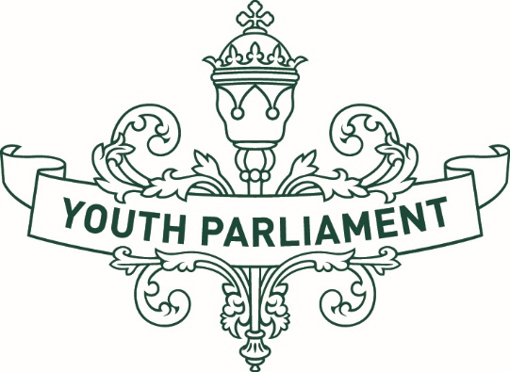

Youth Press Gallery Application Form
Adapted in 2025 by Accessible Formats Service,
Blind Low Vision NZ, Auckland

Transcriber's Note: The logo on the top of the page is Youth Parliament.

Youth Press Gallery Application Form
To apply to be a Youth Press Gallery member, you will need to complete this application form and provide all the following details:
Full Legal Name: ________________________________
Date of Birth: ____________________________________
Preferred pronoun(s): _____________________________
Postal Address: _____________________________________________________________________________________________________________________________________________
Home phone number: _____________________________
Mobile phone number: ____________________________
Email: _________________________________________
Name of school, university or training provider or workplace: _____________________________________

Parent/Guardian Information and consent
Young people who are aged 17 years or under as at Friday 28 February 2025 are required to obtain consent from a parent or legal guardian to apply for a role as a Youth Press Gallery member.
Please complete the following section if you are aged 17 years or under as at Friday 28 February 2025. Your Parent/Guardian will be contacted if your application is successful.
Name of parent or guardian: ________________________
Email Address: __________________________________
Home phone number: _____________________________
Mobile phone number: ____________________________

Applicants need to answer these questions:
Why have you applied to become a member of the Youth Press Gallery 2025? (maximum of 250 words)
Why do you believe you are a good candidate for the role? (maximum of 250 words)

Applicants need to supply the supporting evidence below:
- A current Curriculum Vitae (CV), including full contact details for two referees.
- At least two examples of their work, with at least one of these being a written piece.
- An opinion piece, submitted either in written form (maximum of 500 words) or a video or radio clip (one-two minutes in length), on one of the following topics:
What is an issue affecting young people that members of Parliament (MPs) need to take more notice of and why?
How well do you think MPs are tackling issues that are important to young people? Do they need to be doing more?
End of Youth Press Gallery Application Form

