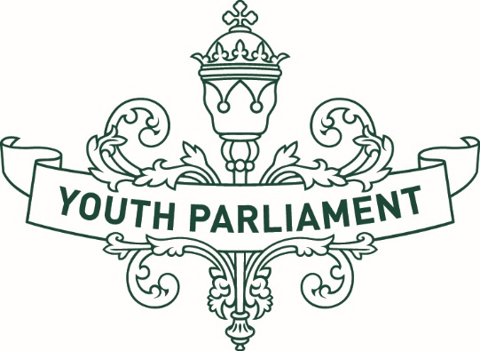

Youth Parliament Application Info 2025
Adapted in 2025 by Accessible Formats Service,
Blind Low Vision NZ, Auckland

Transcriber's Note: The logo on the top of the page is Youth Parliament.

Youth Parliament Application Info
Youth Parliament is a unique youth development opportunity for up to 143 young people from across Aotearoa New Zealand to experience the political process, learn about how government works, and represent their communities as Youth members of Parliament (MPs) or participate as Youth Press Gallery members.
Organised by the Ministry of Youth Development (MYD) — Te Manatū Whakahiato Taiohi, with support from the Office of the Clerk of the House of Representatives — Te Tari o te Manahautū o te Whare Māngai, Youth Parliament 2025 will provide young people aged 16-24 years with an opportunity to develop leadership skills, influence government decision-making, and have their voices heard.
The Youth Parliament 2025 programme will run from Monday 28 April to Friday 29 August 2025, with the two-day event taking place on Tuesday 01 and Wednesday 02 July in the Parliamentary precinct in Wellington. Orientation will also take place in Wellington on Monday 30 June 2025.
The four-month programme allows young people from around Aotearoa New Zealand to actively work and be heard on topics and issues they are passionate about.
Young people aged 16 to 18 years (as at Friday 28 February 2025) are eligible to apply to become a Youth MP, while Youth Press Gallery members must be aged between 16 and 24 years (as at Friday 28 February 2025). All participants will receive training, pastoral support, and guidance along the way.
If you have any questions or would like more information, please contact the Youth Parliament 2025 project team using the following options:
Email us at beheard@youthparliament.govt.nz
Call us between 9.00am and 5.00pm weekdays on
029 948 4067.
If you're deaf, hard of hearing, deafblind, have a speech impairment, find it hard to talk, or its simply your preference, you can text us on 029 948 4067.

How to Apply
All applications open on Monday 03 February 2025 and close at 12.00 noon on Friday 28 February 2025.

Youth MP Application process
Each MP will run their own application process to select a Youth MP. If you would like to represent your community as a Youth MP, you will need to first work out who your local MP is and what their application process is.
Information about electorate and list MPs and how to contact them can be found here: Contact-an-MP-Parliament-website
Or you can check out individual MP's social media to see if they have announced their application process.

Youth Press Gallery Application Form
A panel will select up to 20 young people to participate as Youth Press Gallery members. To apply to be a Youth Press Gallery member, you will need to complete the application form. The link to the online application can be found on the Youth Parliament 2025 website: (Youth-Parliament-2025.nz).
If your preference is to submit an application using the alternate format version, you will find this on the Youth Parliament 2025 webpage. Please complete this and email it to beheard@youthparliament.govt.nz by the closing date.
End of Youth Parliament application info

