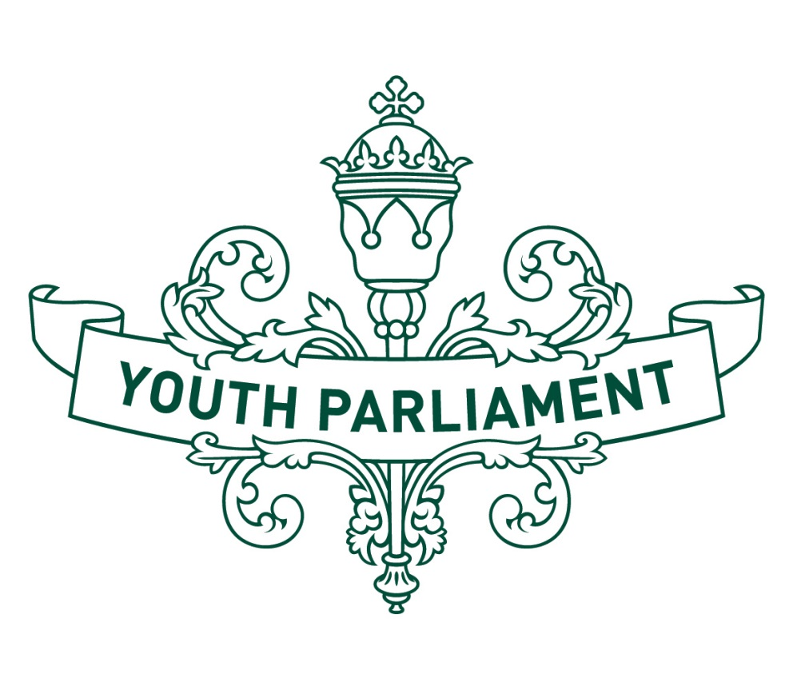
Youth Parliament 2016
Record of Proceedings:
Local Government and Environment Select Committee

Local Government and Environment Select Committee
Inquiry into how much our retail industry is doing to improve New Zealand’s impact on the environment, and if regulation on the cost and usage of plastic bags is required

Recommendations
The Local Government and Environment Youth Parliament Select Committee makes the following recommendations to the Government:
that it introduces legislation to create a 10-cent point-of-sale tax on all plastic carrier bags
that it consider incorporating compulsory environmental sustainability education into the New Zealand curriculum
that it support the efforts of organisations and local government entities to improve sustainability education and awareness in New Zealand
that it forms a working research group to assess and rate the environmental impacts of retail companies’ packaging, with a view to introducing unnecessary packaging regulations
that it introduce subsidies for New Zealand-based companies that use sustainable packaging alternatives to soft plastic packaging
that it initiate research into and subsequent development of sustainable packaging alternatives for New Zealand
  - Introduction
The purpose of this report is to summarise our consideration of how much New Zealand’s retail industry is doing to improve New Zealand’s impact on the environment, and whether regulation on the cost and usage of plastic bags is required. The advice we received indicates that New Zealand uses between 1 and 1.6 billion plastic carrier bags a year. These plastic bags cause environmental damage both through their production and through improper disposal.
We have heard that it is difficult to measure the impact that New Zealand’s retail industry is having on New Zealand’s environment because we do not have comprehensive data. However, we do know that New Zealand’s consumption patterns are similar to those of other highly developed countries, and that these consumption patterns correlate with increased emissions and high resource use and wastage.
We determined that as we do not have conclusive data on these issues, New Zealand should strive to improve our awareness of our retail industry’s environmental impacts. We also determined that although the effect of retail plastic bags is unmeasured, there is general consensus that reducing the environmental impact of these products would be beneficial to New Zealand.
  - Assessing retailers
We noticed that there is a lack of data available about the environmental impacts of retailers in New Zealand. This made it difficult for us to establish what changes are needed, and which initiatives are most environmentally effective, beyond the broad umbrella of “plastic bags are environmentally detrimental and we should generally reduce our use of them”.
Therefore, we recommend that the Government establish a working group to provide impartial assessment of New Zealand’s retail businesses’ environmental impacts. This information would not only improve the Government’s ability to assess the environmental impact of New Zealand’s retail industry, but would also inform programmes that incentivise retailers to switch to more sustainable packaging, reduce unnecessary packaging, and develop regulations to enforce retailers’ use of sustainable packaging.
  - Incentive programmes
We extensively considered the possibility of reducing the environmental impact of New Zealand’s retail industry by penalising environmentally unfriendly producers. However, we concluded that these initiatives would offer limited environmental improvement versus the economic cost to New Zealand’s retail industry.
We felt instead that our initiatives would be better targeted at consumers and retailers. Introducing incentive programmes will allow New Zealand-based companies to reap benefits from choosing sustainable packaging options. We hope that, when combined with the other recommendations we have made in this report, the incentive programmes developed by the working group will make a considerable improvement on the environmental impact of the retail industry.
  - Plastic carrier bags
We recognise that soft plastics used in the retail industry cause environmental issues that should be further addressed. Plastic carrier bags, which we define as “a bag made of a thin, flexible plastic material, which has handles, supplied by a shop to carry goods purchased there”, are one of the most prominent of these soft plastic waste products. We heard that reducing demand for plastic carrier bags and encouraging responsible disposal of these products would have a strong positive impact on New Zealand’s environment.
  - Demand for plastic carrier bags
We were advised by both Ministry for the Environment officials and Retail New Zealand that charging customers for plastic carrier bags is an effective way to reduce demand. In Ireland, the introduction of a 10-cent plastic bag levy reduced plastic bag use by 90 percent. Locally, the Warehouse’s 10-cent carrier bag charge has reduced plastic bag use by 70 percent. Some of us were concerned that retailers could be disadvantaged by self-initiated plastic carrier bag levies. We considered that retailers could lose customers to competitors as a result of this policy unless all retailers charged the same levy. We heard from submitters that retailers have no strong desire to continue using plastic carrier bags as long as they are still able to provide a cost-effective and easy way for their customers to carry purchases.
In light of this consideration, we determined that nation-wide legislation would be the best option to reduce New Zealand’s plastic carrier bag demand. We recommend developing a 10-cent point-of-sale tax on all plastic carrier bags. We hope that this tax would see a similar success rate to Ireland’s plastic carrier bag levy. By reducing demand for plastic carrier bags we hope to reduce the overall environmental impact of their production and encourage a consequent decrease in the waste impact of this soft plastic product.
  - Responsible disposal of plastic carrier bags
We were encouraged to see Packaging Forum New Zealand’s work on soft plastic recycling. We were advised that soft plastic recycling is difficult to make economically viable, so it is encouraging to see the success of this programme. We heard that this recycling system processes all soft plastic, including but not limited to plastic carrier bags. Furthermore, we heard that the local government sector is taking a strong interest in the soft recycling programme. This interest has led to the programme’s strong organic growth. We recommend that the Government continue to support local government and independent organisations’ initiatives to reduce soft plastic wastage.
We also heard that the importance of education was undisputed among submitters. All submitters encouraged us to consider education options as paramount to the ongoing improvement of New Zealand’s environmental sustainability.

  - Education options
We support the general assertion that improved education will reduce inappropriate disposal of plastic bags. We heard from submitters such as Sustainable Coastlines, which runs training programmes aimed at qualifying educators to teach Kiwis about sustainability. We also heard frequent references to the famous “Tidy Kiwi” campaign. We came to the conclusion that education plays an important role alongside formalised sustainability measures, although we are unsure of the relative impact of education programmes. This again highlights the need for impartial analysis of New Zealand’s sustainability. Some of us felt that education programmes will not change people’s habits unless there are also consequences such as fines in place. Others felt that we should focus on education as the best way to create social change and thus reduce demand and the quantities of waste produced.
We agreed that the funds raised by the proposed plastic carrier bag tax could be utilised to offer more support to education programmes such as the “Tidy Kiwi” campaign. However, some members expressed concern that rural areas are less exposed to these campaigns, but are often the places that need them most because of their more remote waste disposal services.
In light of our role as Youth Members of Parliament, we asked what presence sustainability has, if any, in the New Zealand school curriculum. We were surprised that the New Zealand curriculum currently does not include compulsory sustainability education. We feel that incorporating this into the curriculum would be a cost-effective way to ensure that all New Zealanders have a good understanding of basic sustainability concepts. Because of the universality of our school system, we feel that this would address the gaps in rural areas more effectively than existing community outreach programmes such as “Tidy Kiwi”. We urge the Government to consider the possibilities for including compulsory sustainability education in the New Zealand school curriculum.
As Youth MPs, we also felt that young people had a role in being directly involved in championing sustainable packaging options. We considered that the New Zealand Qualifications Authority could develop National Certificate of Educational Achievement accreditation for “environmentally sustainable ambassadors”. This accreditation might include participation in community projects and initiatives that support environmentally sustainable practices, as well as presentation skills as ambassadors share these learnings and experiences in the school context.

  - Appendix to Local Government and Environment Select Committee report
  - Committee procedure
The committee met on 19 and 20 July 2016 to consider the inquiry. The committee received and heard 4 submissions. Evidence was heard from Packaging Forum New Zealand, Ministry for the Environment, Sustainable Coastlines, and Retail New Zealand. Advice was received from the Ministry for the Environment.
  - Committee members
Nina Santos (Chairperson)
Danielle Carson
Chantelle Cobby
Charlotte Cumming
Holly Fletcher
Kelvyn Henare
Justice-Te Amorangi Hetaraka
Nisha Novell
Katie Osborne
Katrina Sneath
Lexi Sutherland
Cameron Wright

