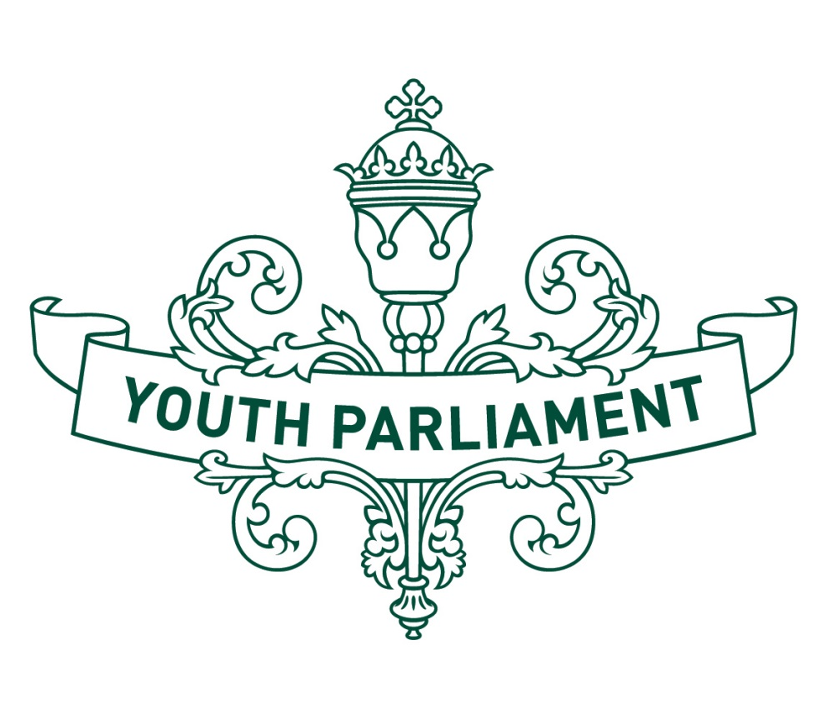
Youth Parliament 2016
Record of Proceedings
Health Select Committee report
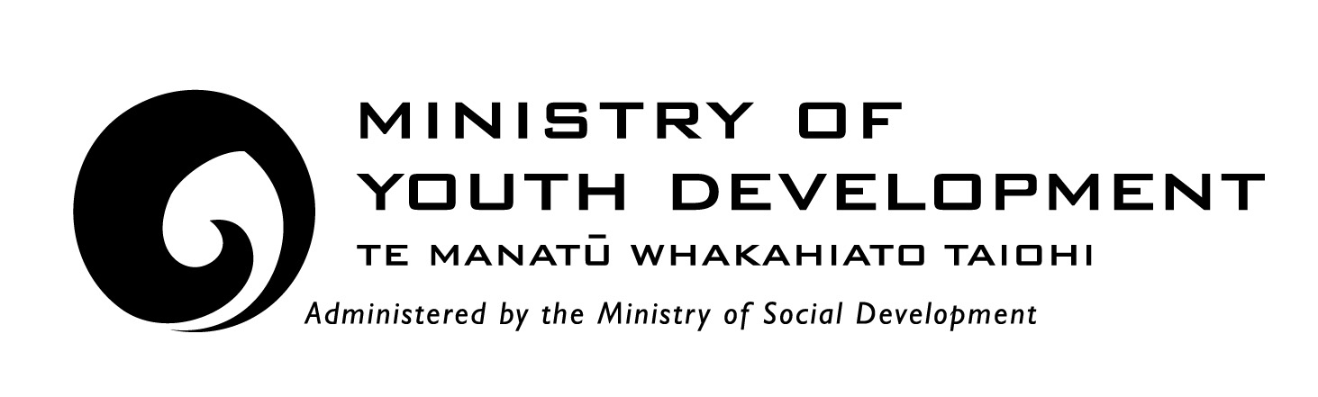

Health Select Committee
Inquiry into how we can better deal with mental health issues and suicide prevention in schools

Recommendations
The Health Select Committee makes the following recommendations to the Government:
- that it provide more resources to schools to promote communication between schools, students and parents about mental health
- that it direct the Ministry of Health and Ministry of Education to identify which isolated areas require additional support for youth mental health services
- that it establish a combined task force comprised of the Ministry of Education and Te Puni Kōkiri officials to create a strategy that encourages relationships between local iwi and hapū, and schools which can support the wellbeing of Māori youth
- that it ensure that all guidance counsellors are appropriately qualified and schools are sufficiently funded to afford to hire qualified guidance staff
- that it provide additional funding to promote alternate forms of education and resources about mental health
- that it request the New Zealand Qualifications Authority (NZQA) partner with schools to investigate ways to make school workloads more manageable for students
- that it incorporates holistic mental health education into required curriculum between years 7 to 13.

  - Introduction
The purpose of this report is to summarise our consideration of how we can better deal with mental health issues and suicide prevention in schools. Young New Zealanders struggle with mental health issues at a much higher rate than other Organisation for Economic Co-operation and Development (OECD) countries. In 2009, New Zealand had the highest youth suicide rate in the OECD although the youth suicide rate has declined by 32.8 percent since the peak rate in 1995. In 2014, only 40 percent of people who committed suicide accessed a mental health service in the year prior.

  - State of youth mental health in New Zealand
Most young people in New Zealand aged between 0 and 19 years are resilient, confident and content and generally have a positive sense of their overall wellbeing. Auckland University’s Youth’12 report found that more than 92 percent of secondary school students reported feeling okay, satisfied, or very happy with their life. However, we are concerned that it is expected that around 20 percent of young New Zealanders will exhibit behaviours and emotions or have experiences that lead to long term consequences.
  - Youth mental health support services
The Government is currently operating a three-tier system to promote well-being, manage issues and respond to crisis. The first tier attempts to build and grow individual resilience by supporting, engaging youth, and resolving conflicts. The school environment is the main way in which the first tier is implemented. National administration guidelines require all school board of trustees to “provide a safe physical and emotional environment for students” while the New Zealand curriculum, when implemented successfully, enables young people to become confident, connected, actively involved and lifelong learners.
The second tier reflects the first layer of supports that are primarily responsive in nature. These supports should be available for young people who demonstrate early signs of wellbeing or mental health problems (often manifested in indirect ways, such as indications that a student is beginning to disengage from education). Examples of a tier two service include guidance counsellors and social workers in schools who are often the first port-of-call for students who are dealing with problems.
The third tier contains supports at the most severe end of the scale, where a young person’s mental wellbeing has become, or is likely to become, severely compromised. Child and Adolescent Mental Health Services (CAMHS) are provided by District Health Boards (DHBs) to deliver specialist mental health and addition services for young people aged 0 to 18. The specific nature of CAMHS differs across DHBs, but generally they serve students who have severe mental health problems. They provide specialist assessment, treatment and consultation, and also make referrals to other services.
  - Current approach to youth mental health
There are a number of developments taking place in the policy context which are designed to improve mental illness prevention and care for young people in New Zealand. The Prime Minister’s Youth Mental Health Project is a four-year (2012-16), cross-agency package of initiatives that aims to improve mental health and wellbeing for young people with, or at risk of developing, mild to moderate mental health issues.
Two other approaches to mental health are the wellbeing indicators set out by the Education Review Office (ERO) and the Suicide Prevention Strategy 2006-16. ERO’s wellbeing indications describe the school values, curriculum and systems that help students experience a high level of wellbeing during their school years. The suicide prevention strategy includes the Suicide Action Plan 2013-16 which specifies the type of activities to be undertaken, identifies which government agency leads which action, and specified outcomes and timeframes.
  - Communication channels
Open communication between schools and families is essential to ensure that there is awareness about mental health issues and outcomes. We were told that strong family communication and support is the foundation for healthy child and adolescent development. This support contributes to building resilience to deal with stress and conflict and may help to prevent suicide. We were then informed that there is often a lack of clear communication between schools and parents about the wellbeing of students which can influence these family bonds.
We are concerned that there is no consistent tool currently being used in schools to inform parents about how to identify risk factors and ensure a safe environment for students to discuss mental health with their family. We stress the importance of providing funding to allow workshops and information evenings to take place regularly so that parents can be advised about how to manage and prompt open conversations with their children about mental health.
  - Community approach
  - Māori and Pacific Island youth
We were concerned to hear that there are several demographics that are heavily over-represented in youth suicide statistics. One demographic that is over-represented is Māori and Pasifika. Over the last five years 188 youths identifying as Māori or Pasifika have died by suicide. That contributes to over 60 percent of total suicide deaths amongst New Zealanders aged 12 to 19.
Community is a focal point for Māori and Pasifika so there would be some benefit in developing strategies for local iwi and hapū to connect with Māori or Pasifika students displaying signs of poor mental health in schools. We recommend that a task force comprised of officials from the Ministry of Education and Te Puni Kōkiri develop a strategy that encourages relationships between local iwi and hapū and schools which can support the wellbeing of Māori youth.
  - Rural areas
We note that most strategies for dealing with mental health in schools are targeted at schools that have sufficient accessibility to required resources. We are concerned that many schools and students in rural or remote areas are not provided the same opportunity to understand mental health or access services because of their geographic isolation. We recommend the Government direct the Ministry of Health and Ministry of Education to identify which schools are being prevented from taking steps towards understanding mental health due to their isolation or size. We also recommend the Ministries consider different ways to encourage community involvement in these areas to reduce the effects their isolation has on the mental wellbeing of local youth.

  - Guidance qualifications
We note that not all guidance staff at schools have appropriate qualifications. We appreciate the importance of volunteers in pastoral care roles but stress the need for trained professionals to hold guidance counsellor positions in schools. Trained guidance staff will be in a better position to handle the concerns of a student and will be able to work with other staff to enhance pastoral care in the classroom as well. We recommend that all guidance counsellors are required to be appropriately qualified and that the Ministry of Education oversee this transitional period, outlining what appropriate qualifications are required. We suggest the Ministry of Education offer opportunities to current guidance staff to complete these qualifications and provide additional funding to schools so they can afford to hire additional guidance staff.
Guidance counsellors play an important role in looking after the mental health of students and are often the first port-of-call for students who are dealing with problems. We believe that fully-qualified guidance counsellors will give students the confidence they need to seek their help and advice and communicate any mental health issues they might have.
  - Education
  - “When Life gives you Lemons”
‘When Life gives you Lemons’ is a book written by two students who have recovered from mental illness during their high school years. The main aim of the book is to provide support to young people and let them know that there are other people in a similar position to them. The book also allows other young people to experience the effects mental illness can have through use of illustrations.
We have identified that there is a lack of effective resources targeted at describing the mental health of youth and recommend the government provide funding to distribute this book to every intermediate and secondary school in the country. This is a book written by young people, for young people and can become a valuable resource. The authors can be considered role models for young people with mental health issues and we suggest the Ministry of Education investigate if there are any opportunities that can facilitate the authors working in an educational spokesperson role.
  - NZQA
Workload and heavy assessment timetables can often be a source of distress for youth in New Zealand. While the individual assessments themselves are considered quite straightforward when compared to overseas examples, the frequency in which they occur is something many students often find difficult to manage. For many students, the school year will go through times of peaks and troughs. A student could be expected to hand in multiple assignments for different classes in the same week and then the same student might not have any formal assessment for the following month.
We recommend that ERO and NZQA further investigate the known correlation between workload and stress levels amongst students. We also recommended that NZQA partner with schools to determine whether it would be suitable to fix the internal assessment dates, in the same way external exam dates are set, so popular internal assessments do not clash and so that students can plan their work schedules well in advance.
  - Health Curriculum
We expressed concern that health and physical education are not compulsory subjects through to year 13 in New Zealand secondary schools. However, we note that not all students are comfortable or interested in selecting physical education as a subject when it becomes optional. We recommend NZQA restructure the curriculum so the core holistic health education programme, with particular emphasis placed on Hauora, is able to be taught through courses other than physical education and remains a compulsory subject from year 7 to 13.

  - Appendix to Health Select Committee report
  - Committee procedure
The committee met on 19 and 20 July 2016 to consider the inquiry. The committee received and heard four submissions. Evidence was heard from Education Review Office, Wellington Coroner Service, Ministry of Health, and Authors of the book: When Life Gives You Lemons. Advice was received from the Ministry of Education.
  - Committee members
Krystal Wright (Chairperson)
Kiri Crossland
Aimee-Chantelle Gough
Huia Jackson
Michael McLeod
Amy Palmer
Keegan Phipps
Hope Sexton
Fenella Smith
Skylar Tangiora
Keryn Tubbs
Gennevieve White
Jenny Wu

